Online Thesaurus

What is Online Thesaurus
# Source: AI Source: Provided by: [Data Path: Persons Table -> ID Column: 1, Name_En Column: Motasem Essam] -> From: [Chatgpt (GPT-4-turbo)] on [7/29/2025]
An Online Thesaurus is a web-based or app-based resource that allows users to find synonyms, antonyms, and related words instantly using digital search functions. These tools often combine the features of traditional and dictionary-style thesauruses, with added benefits like real-time suggestions, usage examples, and interactive features.

🔹 Key Features of an Online Thesaurus
# Source: AI Source: Provided by: [Data Path: Persons Table -> ID Column: 1, Name_En Column: Motasem Essam] -> From: [Chatgpt (GPT-4-turbo)] on [7/29/2025]
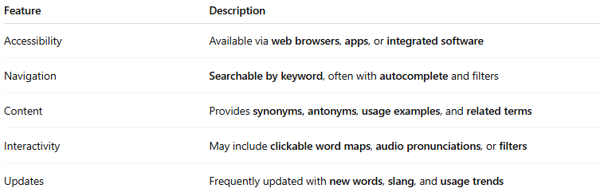
Feature | Description
Accessibility | Available via web browsers, apps, or integrated software
Navigation | Searchable by keyword, often with autocomplete and filters
Content | Provides synonyms, antonyms, usage examples, and related terms
Interactivity | May include clickable word maps, audio pronunciations, or filters
Updates | Frequently updated with new words, slang, and usage trends

🔹 Popular Online Thesauruses
# Source: AI Source: Provided by: [Data Path: Persons Table -> ID Column: 1, Name_En Column: Motasem Essam] -> From: [Chatgpt (GPT-4-turbo)] on [7/29/2025]
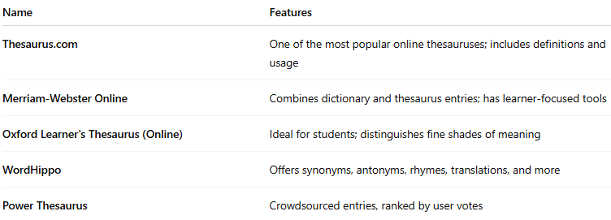
Name | Features
Thesaurus.com | One of the most popular online thesauruses; includes definitions and usage
Merriam-Webster Online | Combines dictionary and thesaurus entries; has learner-focused tools
Oxford Learner's Thesaurus (Online) | Ideal for students; distinguishes fine shades of meaning
WordHippo | Offers synonyms, antonyms, rhymes, translations, and more
Power Thesaurus | Crowdsourced entries, ranked by user votes

🔹 Advantages
# Source: AI Source: Provided by: [Data Path: Persons Table -> ID Column: 1, Name_En Column: Motasem Essam] -> From: [Chatgpt (GPT-4-turbo)] on [7/29/2025]
- Fast and convenient access from anywhere
- Often free to use and mobile-friendly
- Includes modern vocabulary, slang, and idiomatic expressions
- Great for writers, students, and ESL learners

🔹 Limitations
# Source: AI Source: Provided by: [Data Path: Persons Table -> ID Column: 1, Name_En Column: Motasem Essam] -> From: [Chatgpt (GPT-4-turbo)] on [7/29/2025]
- Internet-dependent (unless using a downloaded app)
- Quality and accuracy can vary across platforms
- May overwhelm users with long synonym lists without clear distinctions

